Experiment 4: Vacuum Cleaner Problem

Aim
To implement the Vacuum Cleaner Problem using Artificial Intelligence to clean all dirty rooms.

Objective
To design a simple intelligent agent that checks the state of each room and cleans it if it is dirty.

Algorithm
- Start the program.
- Define two rooms: Room A and Room B.
- Read the status of each room (Clean or Dirty).
- Place the vacuum cleaner in Room A.
- Check the current room.
- If the room is dirty, clean it.
- Move the vacuum cleaner to the next room.
- Repeat the process until all rooms are clean.
- Display the final status and stop.

Python code
room = ["Dirty", "Dirty"]

for i in range(2):
if room[i] == "Dirty":
print("Room", i + 1, "is Dirty")
print("Cleaning Room", i + 1)
room[i] = "Clean"
else:
print("Room", i + 1, "is already Clean")

print("Final Status:", room)

Input
Room 1 = Dirty
Room 2 = Dirty

Flowchart

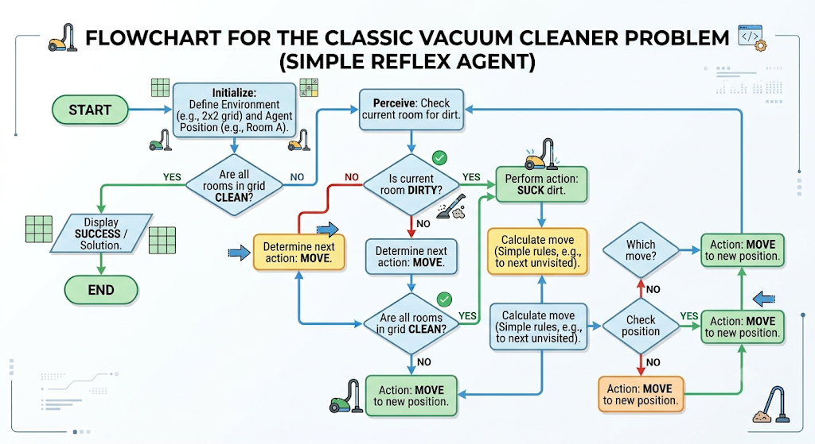

Output
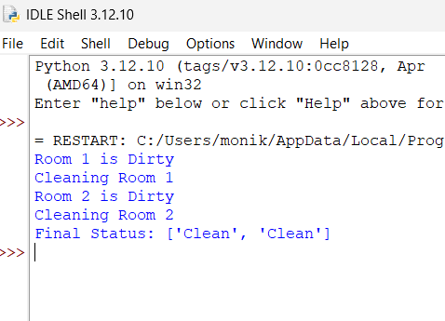

Result
The Vacuum Cleaner Problem was implemented successfully using Python. The intelligent agent checked the status of each room and cleaned all the dirty rooms, leaving every room in the clean state.

